**Python Install**

Before getting into the installation part, let's first look at Python as a programming Language and why it's used mostly in the current technical eco-space.

**What is Python?**

Python is the fastest growing multi-purpose programming language not just amongst Software Engineers, but also amongst Mathematicians, Data Analysts, Data Scientists, Accountants, Network Engineers, and even kids because it is a very beginner friendly programming language.

**Why should one learn Python?**

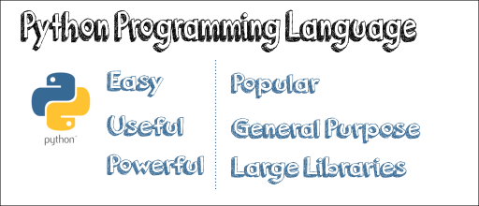

• Python is used by people from various disciplines to perform multiple tasks like Data Analysis, Data Visualization, Artificial Intelligence, Machine Learning, and Automation. This is one of the significant uses of Python amongst people who are not software developers.

• A lot of the times, we do kinds of stuff which are repetitive and boring. It often creates the resource and budget constraints for companies who propose to automate the process to ensure the fluidity of the business. Python could be used to automate those tasks like copying files and folders around, renaming them, uploading to the servers, etc.

• Most companies have to work continuously with Excel spreadsheets, PDF’s, CSV files, download websites and parse them. All of these activities, however, could be automated using Python as well.

• Python is used to build web, mobile, and desktop applications as well as software testing and even hacking which further justifies its multi-purpose functionality.

**Now, questions could be raised that these above activities could be done with other languages as well. So why Python?**

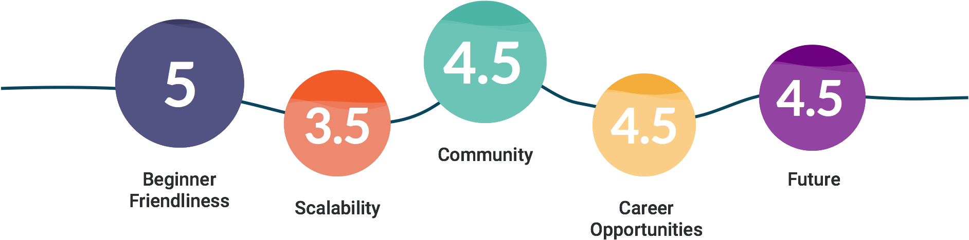

Here’s why!

**• Fewer lines of code: -** Python can solve complex problems in less time and with fewer lines of code. Let’s say, for example, we want to extract the first three letters of the text “Hello World” stored in variable ‘str.’ Below is how we would write in different languages.

o C# - str.Substring(0,3)

o Javascript – str.substr(0, 3)

o Python – str[0:3]

As we can see, python is short and clean to use.

**• High-Level language: -** Python is a high-level language, so we do not have to worry about complex tasks such as memory management, as you do in C++.

**• Cross Platform: -** It is a cross-platform language which means we can build and run Python applications on Windows, Mac, and Linux.

**• Huge Community: -** Python has a large community, so whenever we get stuck, there is always someone out there to help.

**• Large Ecosystem**: -This is called the snowball effect. As more companies use Python, the more resources there are for it. Python has a whole host of libraries, frameworks, and tools which means whatever we want to do; it’s more likely that someone else might have already done it before as the language has been around for over 20 years.

**Installation: -**

So far, we have discussed a bit of Python’s history, its applications and its popularity in today’s world, but now comes the part that we all have been waiting for. Time to get our hands dirty and install python.

The installation process will have two parts: -

1. Downloading and Installing Python for windows from the official website
2. Installing an IDE ( We will use PyCharm)

**Part 1:-** Downloading and Installing Python from the official website based on the following steps.

* Visit the official website and go to <https://www.python.org/downloads/>. Click Download Python 3.7.2 button.

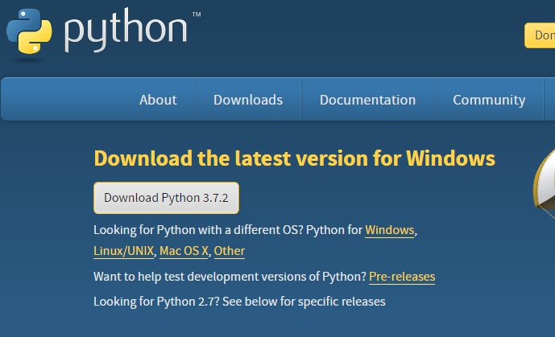

* Once we click the download button, it might ask for a location to save the file. Select an appropriate location (Here, we have created a new folder Python-3.7.2 in our C drive and clicked the Save button) and then proceed towards the installation.

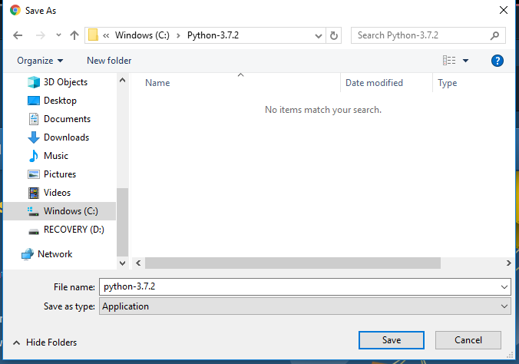

* Double Click the downloaded .exe file and select the Add Python 3.7 to PATH checkbox below to ensure it is automatically added to the Windows Environment variable. Else we have to do it later on manually. Once the box is checked, click on Install Now.

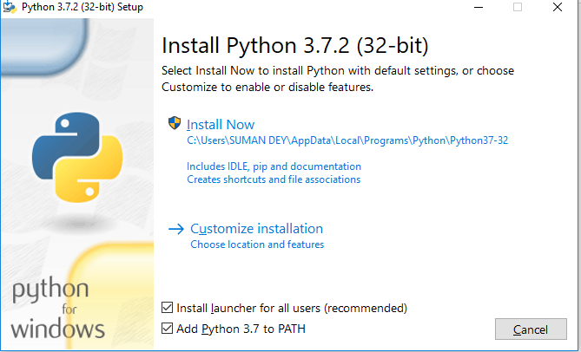

* The installation is in progress here.

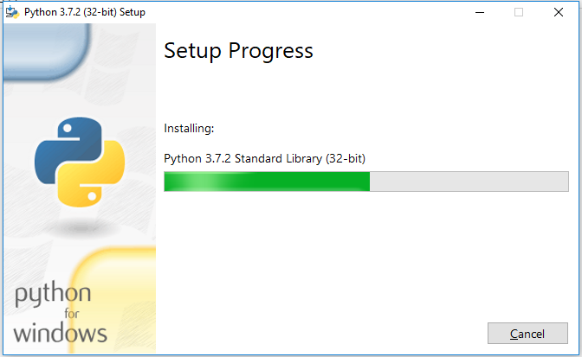

* Once the setup is complete, we will get a message like this. Click on the Close button to finish the installation.

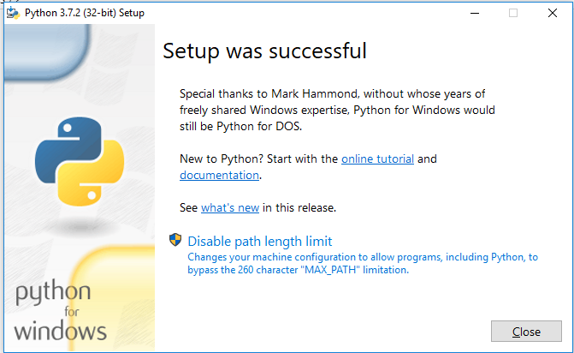

* Once Python is installed, go to the Windows search bar and type Python, and we will find a desktop app called Python 3.7 (32-bit). Click on that and a command prompt while open as below.

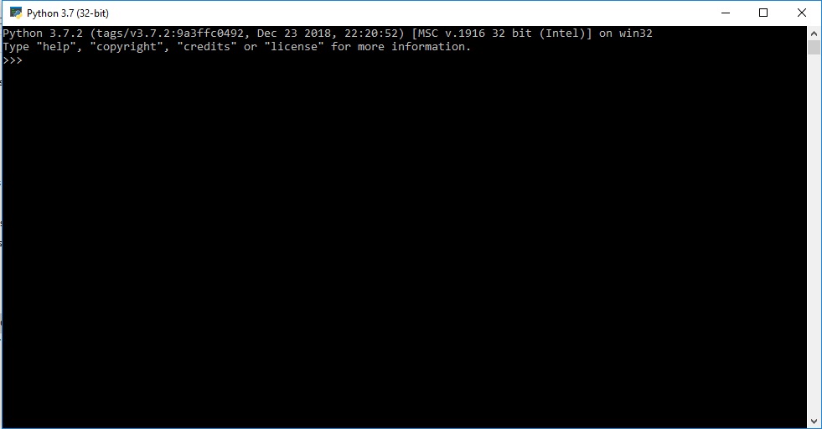

* Now we write our first program which will print ‘Python Installed Successfully’ in the prompt.

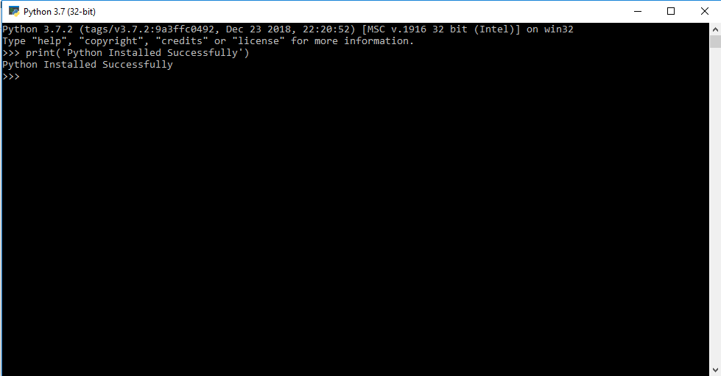

**Part 2:-** Installing PyCharm

PyCharm is one of the sought after Integrated Development Environment among Python programmers. It comes in two editions –

1. **The Community Edition**, which is free and supports only pure Python Programming but has some features like code completion, refactoring, debugging and integration with version control systems.
2. **The Professional Edition** is built on top of the Community Edition and includes additional support like Django, Flash, and SQLAlchemy.

Now, we will download and install the Community edition as shown below.

* Visit <https://www.jetbrains.com/pycharm/download/> and click on the Download button below the Community.

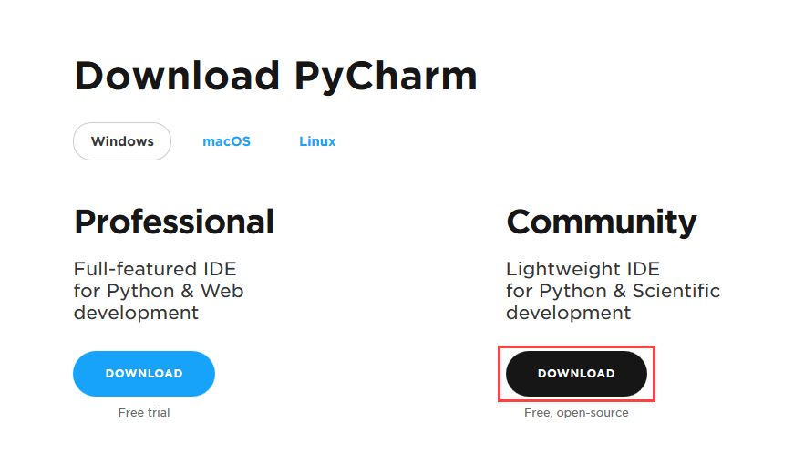

* Similar to downloading Python, we can select the location to save the file and then click on the downloaded .exe file and select next.

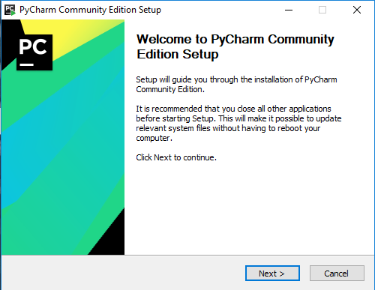

* Browse to the location where you want to install the PyCharm IDE and select Next.

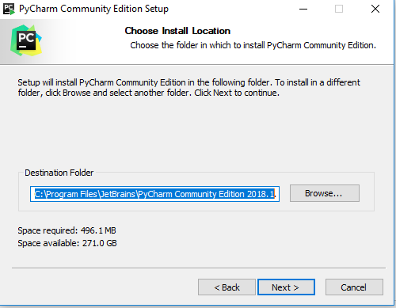

* You can create a Desktop Shortcut if you want, and select either 32-bit or 64-bit launcher based on your system’s processor.

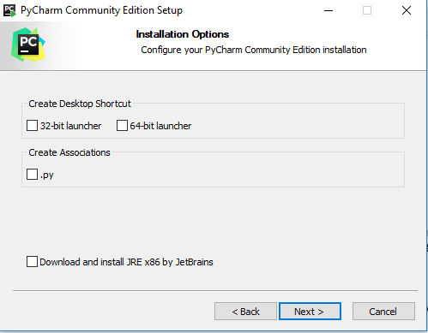

* Keep selected JetBrains in the Start Menu Folder and click Install.

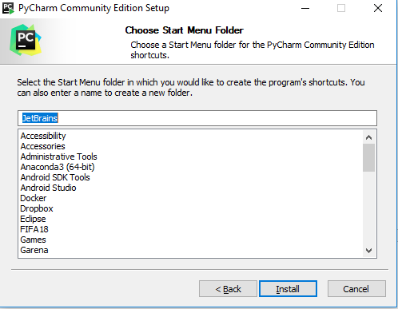

* The Installation will continue and once finished, it would prompt with the below message screen. We will check the Run PyCharm Community Edition box, and then click Finish.

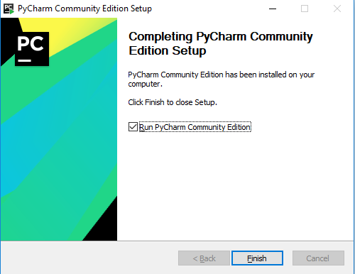

* The IDE will start, and the following screen would appear.

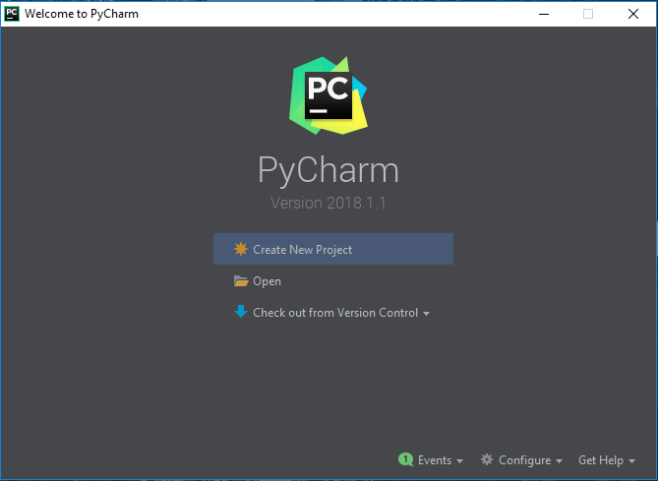

Thus we have successfully installed both Python and PyCharm IDE for Windows.

**Latest Trends in Python:-**

**Python 3.8.0a1 is now available for testing** – The Python development team is expected to fully release the latest 3.8 version this year with the first of the four planned alpha releases, i.e., 3.8.0a1 is available for testing, but it’s not ready for production environments at the moment. It could be downloaded from here - <https://www.python.org/downloads/release/python-380a1/>

The first phase has a PEP 572 implementation which creates another way to assign variables within an expression using the notation NAME: = expression.

The detailed changes are available here - <https://docs.python.org/3.8/whatsnew/changelog.html>

**Conclusion**: -

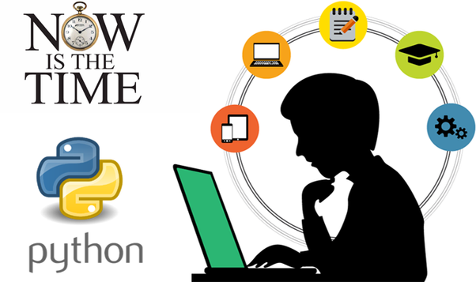

Technically everything that is done with Python could be done with other programming languages as well, but Python’s simplicity and elegance have made it grow way more than other programming languages, and thus it has become the number one language employers are looking for.

So, whether you are a programmer or an absolute beginner, learning Python would open up a plethora of job opportunities. The average Python developer earns more than 100k dollars a year.

Start learning Python from today - <https://www.python.org/doc/>